**Configuring Mongo DB In Command Prompt**

1. Run Command Prompt As Administrator
2. Follow Below Steps

C:\

C:\>mkdir data\db

C:\>mkdir data\log

C:\>cd progra*

C:\Program Files>cd mon*

C:\Program Files\MongoDB>cd ser*

C:\Program Files\MongoDB\Server>cd 3.2

C:\Program Files\MongoDB\Server\3.2>cd bin

Create .cfg File and copy it to “**C:\Program Files\MongoDB”**

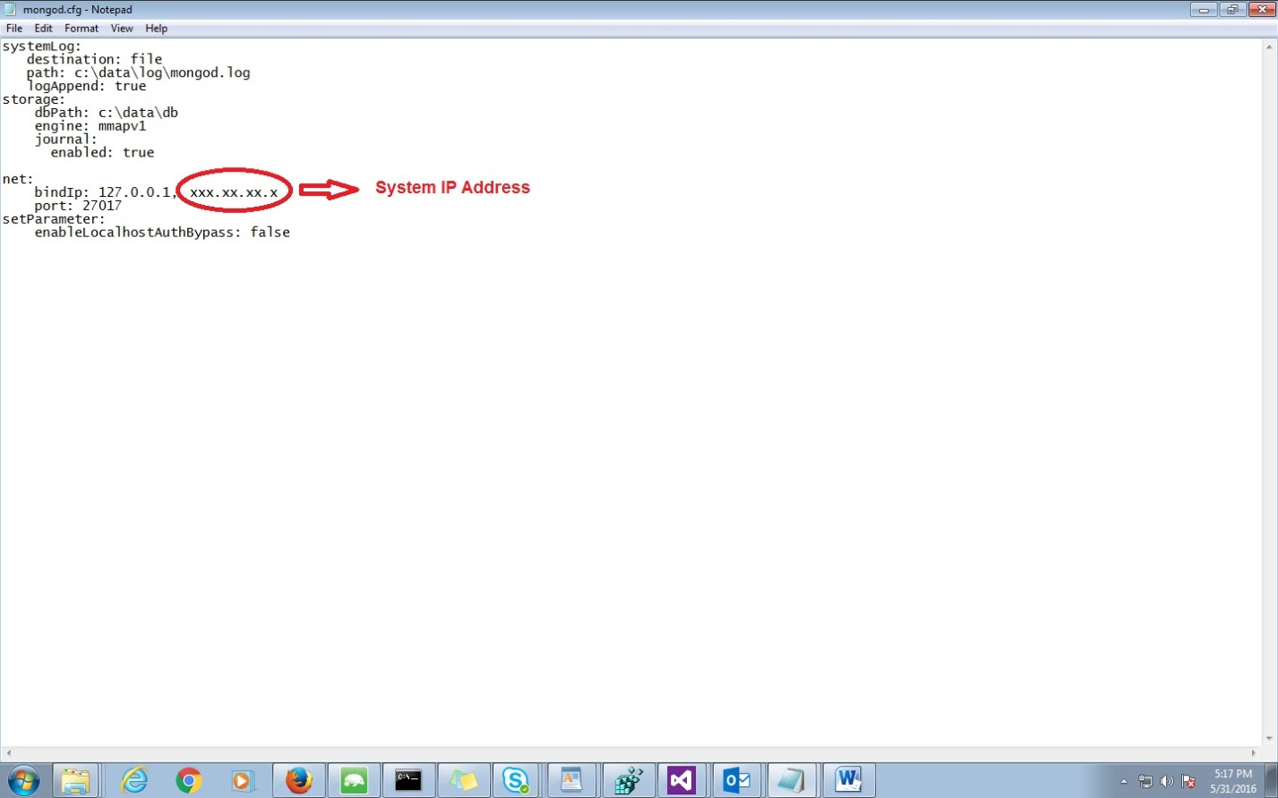



In Command Prompt,

**C:\Program Files\MongoDB\Server\3.2\bin>mongod.exe --config "C:\Program Files\Mo**

**ngoDB\mongod.cfg" –install**

C:\Program Files\MongoDB\Server\3.2\bin>**net start mongodb**

**You will get a message**

**“The MongoDB service was started successfully.”**

Then

C:\Program Files\MongoDB\Server\3.2\bin>mongo.exe

To Connect to Remote MongoDB

C:\Program Files\MongoDB\Server\3.2\bin>mongo **Remote System IP Address:Port**

**Configuring Mongo DB to use Simple Rest API:**

* Add “rest=true” and “nohttpinterface=false“ in cfg file
* Launch Rest URL(“http://172.26.1.74:28017/CodeData/test_collection/”) in browser.

(REF: <https://docs.mongodb.com/ecosystem/tools/http-interfaces/>)

**Creating user in Mongo DB:**

* use CodeData

db.createUser(

{

user: "a",

pwd: "123",

roles: [ { role: "readWrite", db: "CodeData" } ]

}

)